**LAB 4: ACTIVE BAND-PASS FILTER PROJECT**

**ELEC3509 A-L6**

**Name:** Youssef Ibrahim

**Student #:**101103080

**Instructor:** Qi-Jun Zhang

**INTODUCTION**

**THEORY AND DESIGN**

$$X=101103080$$

$$A=X mod 1031=127$$

$$B=X mod 1033=271$$

$$f_{-3dB Lower}=\frac{A^{5}}{5.534*{10}^{9}}-\frac{A^{4}}{2.11*{10}^{6}}+\frac{A^{3}}{2287}-\frac{A^{2}}{6.1}+20.2A+750=1449.64 Hz$$

$$δ=-\frac{B^{2}}{180000}+\frac{B}{173}+0.5=1.66$$

$$f_{-3dB Upper}=f_{-3dB Lower}\left(1+δ\right)=3856.04 Hz$$

$$BW=2π\left(f_{-3dB Upper}-f_{-3dBLower}\right)=15119.87 rad/s$$

$$w_{o}=2π\sqrt{f_{-3dB Upper}*f_{-3dB Lower}}=14855.28 rad/s$$

$$Q=\frac{w_{o}}{BW}=0.983$$

$$H_{2}\left(S\right)=\frac{0.7079*0.7079}{S^{2}+0.6449S+0.7079}$$

$$H_{2}\left(S\right)=\frac{a}{S^{2}+bS+c}$$

$$a={0.7079}^{2}=0.5011$$

$$b=0.6449$$

$$c=0.7079$$

$$S→\frac{S^{2}+w_{o}^{2}}{BW}=\frac{Q[{\left(\frac{S}{w_{o}}\right)}^{2}+1]}{\left(\frac{S}{w_{o}}\right)}$$

$$Q=\frac{w_{o}}{BW}$$

$$S→\frac{S^{2}+w_{o}^{2}}{BW*S}$$

By substituting this equation into the previous one we get

$$H_{4}\left(S\right)=\frac{aBW^{2}S^{2}}{S^{4}+bBWS^{3}+\left(2w_{o}^{2}+c{BW}^{2}\right)S^{2}+bBWw_{o}^{2}S+w_{o}^{4}}$$

$$H_{4}\left(S\right)=\frac{\left(114.56*{10}^{6}\right)S^{2}}{S^{4}+\left(9750.80\right)S^{3}+\left(603.19*{10}^{6}\right)S^{2}+\left(2.15*{10}^{12}\right)S+\left(4.8699*{10}^{16}\right)}$$

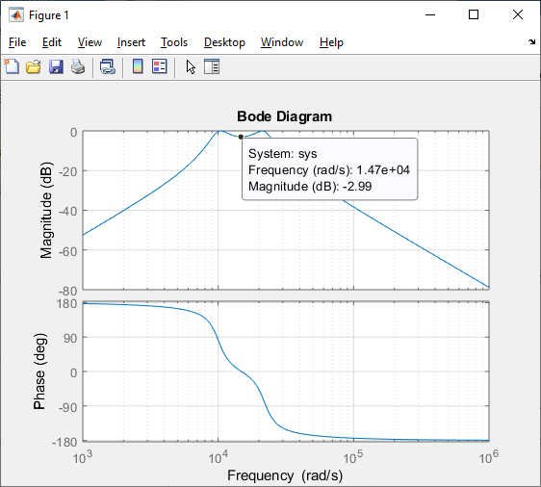

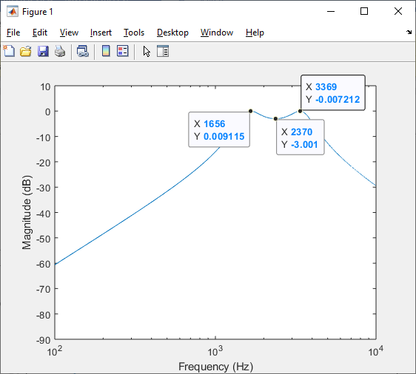

$$Gain=$$

$$q^{2}=\frac{Q}{b}\left(\left(\frac{2Q}{b}+\frac{c}{2bQ}\right)+\sqrt{{\left(\frac{2Q}{b}+\frac{c}{2bQ}\right)}^{2}-1}\right)=10.78$$

$$q=3.28$$

$$w_{02}=\frac{aq}{2Q}+\frac{1}{2}\sqrt{\frac{b}{Q^{2}}-\frac{1}{q^{2}}}=1.4759$$

$$w_{01}=\frac{1}{w_{02}}=0.6776$$

$$H_{BP}\left(S\right)=\frac{{aBW}^{2}S^{2}}{\left(S^{2}+\frac{{w_{o}w}_{01}}{q_{1}}S+{\left(w_{o}w_{01}\right)}^{2}\right)\left(S^{2}+\frac{w_{o}w_{02}}{q_{2}}S+{\left(w_{o}w_{02}\right)}^{2}\right)}$$

$$H_{A}\left(S\right)=\frac{10703.27S}{S^{2}+\frac{14855.28*0.6776}{3.28}S+{\left(14855.28*0.6776\right)}^{2}}=\frac{10703.27S}{S^{2}+3068.88S+10.132*{10}^{7}}$$

$$H_{B}\left(S\right)=\frac{10703.27S}{S^{2}+\frac{14855.28*1.4759}{3.28}S+{\left(14855.28*1.4759\right)}^{2}}=\frac{10703.27S}{S^{2}+6684.42S+40.070*{10}^{7}}$$

$$H_{4}\left(S\right)=\frac{10703.27S}{S^{2}+3068.88S+10.132*{10}^{7}}*\frac{10703.27S}{S^{2}+6684.42S+40.070*{10}^{7}}$$

HA graph below

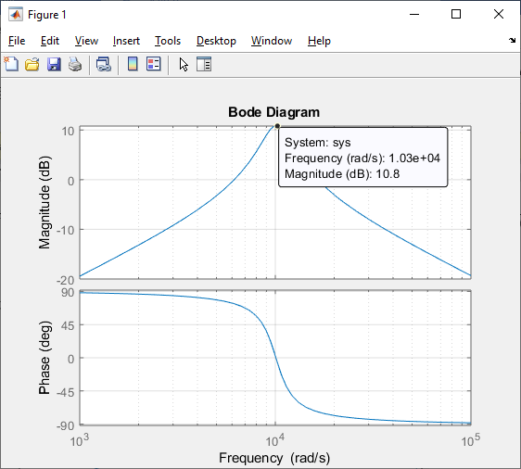

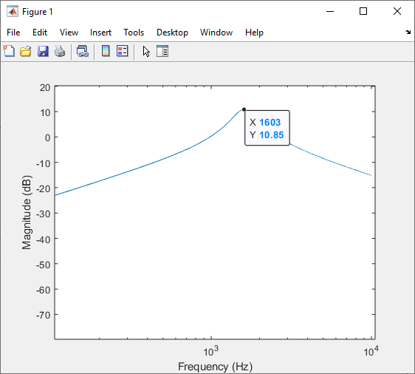

$$Gain=10.8 dB$$

HB graph below

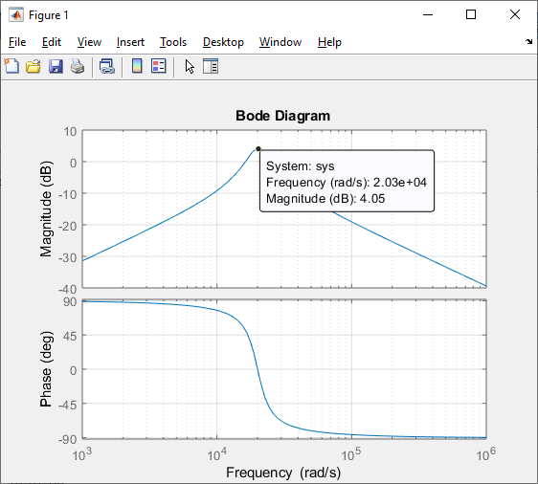

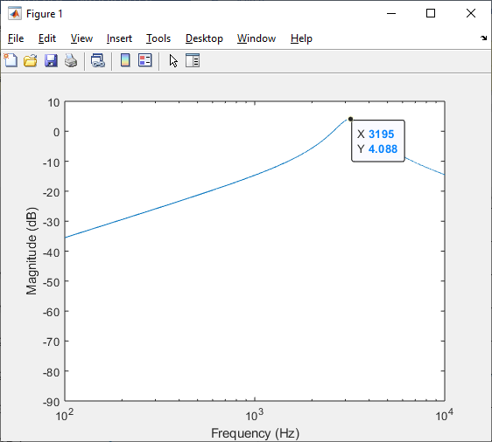

$$Gain=4.05 dB$$

$$H_{4}\left(S\right)=\frac{\left(10703.27\right)S}{S^{2}+\left(12142.08\right)S^{3}+\left(24559.93\right)S^{2}+\left(180.37*{10}^{6}\right)S+\left(220.68*{10}^{6}\right)}$$

$$H\left(S\right)=\frac{S^{2}\left(\frac{C_{1}}{C}\right)+S\left(\frac{1}{C}\right)\left(\frac{1}{R_{1}}-\frac{r}{R_{3}R}\right)+\frac{1}{C^{2}R_{2}R}}{S^{2}+S\frac{w_{o}}{Q}+{\left(\frac{1}{RC}\right)}^{2}}$$

$$H\left(S\right)=\frac{\frac{S}{C}\left(\frac{1}{R_{1}}-\frac{r}{RR_{3}}\right)}{S^{2}+S\frac{w_{o}}{Q}+{\left(\frac{1}{RC}\right)}^{2}}$$

$$H\left(S\right)=\frac{aS}{S^{2}+bS+c}$$

$$H_{A}\left(S\right)=\frac{10703.27S}{S^{2}+3068.88S+10.132*{10}^{7}}$$

$$R_{3}=18 kΩ; R_{1}=5.6 kΩ$$

Corner Frequency

$$w_{oA}=\frac{1}{RC}=\sqrt{c}=\sqrt{10.132*{10}^{7}}=10065.784 rad/s$$

Bandwidth

$${BW}_{A}=\frac{w_{oA}}{Q_{A}}=b=3068.88 rad/s$$

Quality Factor

$$Q_{A}=\frac{w_{oA}}{{BW}_{A}}=\frac{10065.784}{3068.88}=3.280$$

Gain from plot is

$$A_{VA}=10.85 dB$$

Capacitance Value

$$C_{A}=22 nF$$

Resistance Values

$$R=\frac{1}{w_{oA}C_{A}}=\frac{1}{\left(10065.784\right)*\left(22 nF\right)}=4515.75 Ω$$

$$R_{q1}=R*Q_{A}=\left(4515.75 Ω\right)*\left(3.28\right)=14811.65 Ω$$

Assume $r_{A}=R_{q1}$

$$r_{A}=\frac{R_{3}R}{R_{1}}-aC_{A}RR_{3}=\frac{18000*4515.75}{5600}-\left(10703.27*22*{10}^{-9}*18000\right)=14510.67 Ω$$

$$H_{B}\left(S\right)=\frac{10703.27S}{S^{2}+6684.42S+40.070*{10}^{7}}$$

$$R_{3}=68 kΩ;R_{1}=2.2 kΩ$$

Corner Frequency

$$w_{oB}=\frac{1}{RC}=\sqrt{c}=\sqrt{40.07*{10}^{7}}=20017.49 rad/s$$

Bandwidth

$${BW}_{B}=\frac{w_{oB}}{Q_{B}}=b=6684.42$$

Quality Factor

$$Q_{B}=\frac{w_{oB}}{{BW}_{B}}=\frac{20017.49}{6684.42}=2.995$$

Gain from plot

$$A_{vB}=4.088 dB$$

Capacitance Value

$$C_{B}=33 nF$$

Resistance Values

$$R=\frac{1}{w_{oB}C_{B}}=\frac{1}{\left(20017.49\right)\left(33 nF\right)}=1513.83 Ω$$

$$R_{q2}=R*Q_{B}=\left(1513.83\right)\left(2.995\right)=4533.91 Ω$$

$$r_{B}=\frac{R_{3}R}{R_{1}}-aC_{B}RR_{3}=\frac{68000*1513.83}{2200}-10703.27*33*{10}^{-9}*1513.83*68000=10431.73 Ω$$

**SIMULATION**

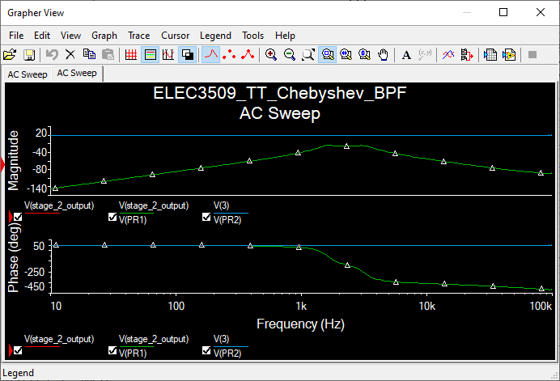

**RESULTS AND ANALYSIS**

|  |  |  |  |
| --- | --- | --- | --- |
|  | **Theoretical** | **Simulated** | **Simulated Standard** |
| $$A_{mid}$$ |  |  |  |
| $$f_{high}$$ |  |  |  |
| $$f_{low}$$ |  |  |  |
| $$BW$$ |  |  |  |
| $$w_{o}$$ |  |  |  |

**CONCLUSION**

|  |
| --- |
| % Set the numerator and denominator of the TF.  % In this case numerator is a constant.  Num = [(3.9476e7)^2] ;  % Denominator = sˆ4 + 16419*sˆ3 + 134787490*sˆ2 + 648191274000*s + 1558473004000000  Dem = [1 16419 134787490 648191274000 1558473004000000];  % Set the frequency range to plot and the value of s.  f = 100:1:1e4;  s = 2*pi*f*j;  % Determine the magnitude of the frequency response in dB.  FR = 20*log10(abs(polyval(Num,s) ./ polyval(Dem,s)));  % Plot the result.  semilogx(f,FR)  xlabel ('Frequency (Hz)')  ylabel ('Amplitude (dB)')  axis ([0 1e4 -90 10]) |

